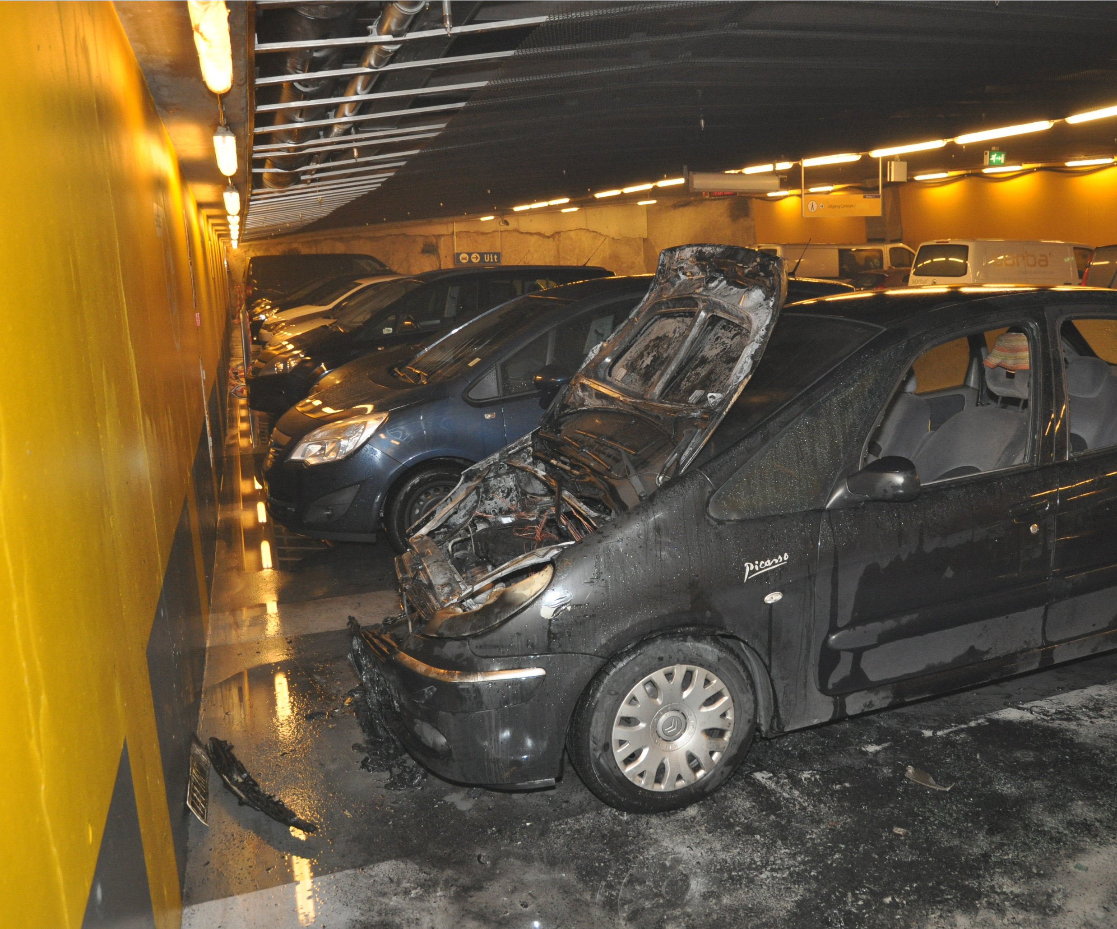
Research sprinkler system parking garage

Institute for Physical Safety
P.O. Box 7010
6801 HA Arnhem
Kemperbergerweg 783, Arnhem www.ifv.nl info@ifv.nl
026 355 24 00

Colophon

Institute for Physical Safety (2021). Research sprinkler system parking garage .
Arnhem: IFV.

Client: | Ministry of the Interior and Kingdom Relations (BZK)
Contact person: | Marcel Beam
Title: | Research sprinkler system parking garage
Date: | 26 March 2021
Status: | Definitive
Version: | 1.0
Authors: | ing. L. de Witte and ing. P.J. van der Graaf
Project leader: | P.J. van der Graaf
Review: | Ing. R. Hagen MPA
Responsible: | Ing. R. Hagen MPA

Summary
The Ministry of the Interior and Kingdom Relations (BZK) has proposed to the Building Regulations Consultation Platform (OPB) a number of draft regulations for the application of an automatic extinguishing system. in parking garages. The intention of het
The Ministry is to include this in the Buildings and Living Environment Decree from 2022 onwards.
(Bbl). The OPB has asked for a further substantiation of that proposal. The Ministry of the Interior and Kingdom Relations has asked the IFV to draw up this substantiation. Based on a literature study, desk research and a brief field study at a number of safety regions, the following questions are answered in this research:
- What are the fire safety risks of parking garages under buildings?
- Why is an automatic extinguishing system a better way to control these fire safety risks than:
  - the application of fire ventilation with an improved fire brigade deployment
  - applying a burn-out scenario?
- Provide a substantive justification for the choice to apply the eis for an automatic extinguishing system to buildings in which overnight stays can be spent ('sleeping buildings') and of which a floor of a residential area is located > 13 metres above the measuring level. Ditto for parking garages > 1,000 m2.

Brandveiligheidsrisico’s
The likelihood of a 'travelling fire' has increased due to the growing use of plastics in vehicles and possibly also as a result of an increase in electrically powered vehicles and other vehicles. with an alternative energysupply in parking garages. As a result, the risk of a long-term thermal load on the structure has increased compared to the principles underlying the regulations for parking garages. This increases the risk of branddoorslag, collapse of (supporting) constructions and victims . In addition, the smoke production from fires in parking garages has also increased: even with a limited fire size, a large amount of smoke is produced that quickly spreads through the garage. . Even if the fire-resistant separation structures meet the performance requirements of the Building Decree 2012, there is still a chance that smoke will spread further through openings. to the buildings above (obstruction of escape routes) and the surrounding area (risks due to : opening of doors, cracks and seams, penetrations, openings in the façade and ventilation ducts). As a result, sleeping persons, reduced self-reliance or large numbers of people walk above, next to, below or in the vicinity of parking garages extra risks. Finally, the chance of a rapid firefighting of a fire in the parking garage has been greatly reduced. The basic starting point for parking garages is that an offensive fire brigade deployment in the parking garage is not possible in advance . However, the demand for help for the fire brigade is increasing: in addition to the increased risks associated with a fire brigade deployment aimed at extinguishing (including for the fire brigade staff), the risks also increase. of a fire brigade effort aimed at rescue (both for the users and the fire brigade personnel).

Automatic blusinstallation
With an automatic extinguishing system, a fire is (long-term) independently limited to a small number of cars, so that a 'travelling fire' is prevented. A local fire results in a short-term (local) limited thermal load on the supportingstructure of the garage. The chance that people present can flee independently increases and the demand for help for the fire brigade (extinguishing and rescue) decreases. In addition, it increases the chance that the fire brigade can make an effective indoor deployment and keep the situation manageable. With an automatic extinguishing system, almost all the risks mentioned are (strongly) limited, in contrast to the two other concepts that are based on a combination of mitigation measures. Such measures do not outweigh a source mitigation device in the form of an automatic extinguishing system.

Substantive substantiation
The following list shows the substantive substantiation of the requirement for the automatic extinguishing system per category:
> | Criterion: sleeping building > 13 m (category B and D): the higher the building, the greater the effects of a fire can be (including an increase in the risk of casualties). The limit value of 13 m is in line with a limit value used in the Building Decree 2012.
> | Criterion: parking garage > 1,000 m² (category C and D): the larger the usable area of the parking garage, the greater the chance of a long-term fire (travelling fire), and the greater the chance on a long-terme high thermal load on the supporting and separation structures of the parking garage. The surface criterion of 1,000 m2 is in line with the maximum surface area that a fire compartment may have in a parking garage.
> | Combination criterion parking garage < 1,000 m² and sleeping building > 13 m (category B): the effects of a fire in a parking garage < 1,000 m² are comparable to those of a parking garage > 13 m for sleeping buildings parking garage > 1,000 m2, combined with the fact that the effects of a fire increase as the building height increases.
> | Combination criterion parking garage > 1,000 m² and sleeping building < 13 m: the study revealed two specific situations. The most urgent category is the situation where the sleeping building has only one escape route that leads through a space that is accessible from the parking garage. In that case, it is most likely that this only escape route will be covered in smoke as a result of a fire in the parking garage and the risks are greater. compared to the situation in which there are two escape routes that lead through a space that is accessible from the parking garage.

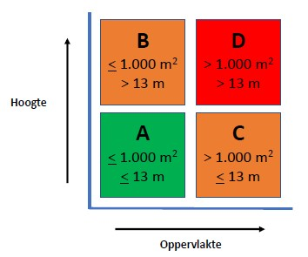

Contents
Summary 3
Introduction 7

1 Brandveiligheidsrisico’s 11
1.1 The fire 11
1.2 The building 15
1.3 Intervention 18
1.4 Man 20
1.5 The surroundings 20
1.6 Conclusion based on the risks described 20

2 Automatic blusinstallation 22
2.1 Preventing a risky situation (definition) 22
2.2 Purpose and sub-goals 23
2.3 Influence of automatic extinguishing system and comparison with other facilities 23
2.4 Summary Table 28

3 Substantiation criteria 'sleeping buildings' 30
3.1 Current annotation 31
3.2 Field research 32
3.3 Analysis 34

4 Conclusions 38
4.1 Answering research question 1 38
4.2 Answering research question 2 39
4.3 Answering research question 3 39

5 Recommendations 41
Bibliography 42
Annex 1: Results of the field study 43

Introduction

Inducement
The Ministry of the Interior and Kingdom Relations (BZK) has presented a number of draft regulations to the Building Regulations Consultation Platform (OPB) for the application of automatic extinguishing systems. in parking garages. The Ministry's intention is to include the regulations in the Buildings and Living Environment Decree (Bbl) from 2022 onwards. The OPB has asked for further substantiation of these provisions. The Ministry of the Interior and Kingdom Relations has asked the IFV to draw up this substantiation.

The fire safety of parking garages has been the subject of discussion for a long time. In 2015, DGMR was commissioned by the Ministry of the Interior and Kingdom Relations to draw up the report Research into the Directive on fire safety in parking garages (DGMR, 2015). At the beginning of 2020 TNO, also commissioned by the Ministry of the Interior and Kingdom Relations, published the report Risks in parking garages as a result of electric and hydrogen-powered passenger cars - International Ventilation (TNO, 2020). published. In July 2020 , the Institute for Physical Safety, together with the Dutch Fire Brigade NL, provided the publication Fire safety of parking garages with electrically powered vehicles (IFV, 2020a). Finally, ce Delft has drawn up the publication Safety and electric passenger cars in November 2020 (CE Delft, 2020).

In addition, NEN is currently working on a standard for the integral assessment of the fire safety of parking garages. This standard will contain a determination method by which a package of safety measures for a fire-safe parking garage can be chosen. In addition to structural facilities, an automatic extinguishing system is also an option. However, the Netherlands Fire Brigade has requested the Ministry of the Interior and Kingdom Relations to have an automatic extinguishing system for the most risky parking garages (such as parking garages under residential buildings). directly in the building regulations . This should prevent the application of the NEN standard in certain situations from leading to measures that are (too much) based on the deployment of the fire brigade.

Context
In recent years, the fire brigade has increasingly been confronted with relatively large fires in parking garages. Examples of such fires can be found everywhere, internationally (Paris, Liverpool and Stavanger) and nationally (Oosterhout and Alkmaar). An analysis shows that the standard design principles of parking garages are increasingly lagging behind the reality of the fires (IFV 2020a).

The design principles of regulations, standards and guidelines are often based on:
> old honorary vehicles running on fossil fuels and designed with a small amount of plastics
> a local fire scenario (single cars)
> an unrealistically estimated fire brigade deployment.

Modern vehicles, partly due to the use of many plastics, have a higher fire load and a greater fire capacity than older models. Parking garages are relatively large spaces with a limited height, and all this together makes that fire in modern vehicles in parking garages results in very high temperatures and dense black smoke. Due to the heat, the loss of vision, the large deployment depths and the difficult orientation in parking garages, reconnaissance and combating by the fire brigade are difficult and risky tasks. With the increased fire spreading speed and the increased fire capacity of modern cars – both in closed and open car parks and even in open car parks – the likelihood that a car fire develops into a prolonged, intense fire that eventually involves a large number of vehicles.

Another development is that the number of alternative fuel vehicles is increasing significantly as a result of the energy transition. In addition to the above-mentioned problems, this increase obviously also has consequences for the parking garages, where, for example, electrically powered vehicles can be found to an increasing extent , just as special charging facilities. Electrically powered vehicles often use lithium-ion battery packs as energy storage. This developmentposes an additional risk to the existing activity of car parks.

Fires in such battery packs differ in particular in the fire course and the burning time. This also applies to hydrogen fuel cells. In addition, the classification of the highly toxic and corrosive substances released in the event of a fire in an electrically powered vehicle differs from the substances released during fire in a conventional vehicle. These risks in addition to the above-mentioned problems ensure that firefighting, certainly in parking garages, can only take place to a limited extent or not at all. In the publication Parking garages with electrically powered vehicles (IFV 2020a), a set of possible measures has been formulated with which the fire safety of parking garages can be increased. One of them is the use of an automatic fire extinguishing system, such as a sprinkler or water mist system – and that is what this research is about.

Problem definition
The Ministry of the Interior and Kingdom Relations has made a proposal in the OPB to prescribe an automatic extinguishing system in the building regulations in parking garages under certain buildings. The OPB has asked the Ministry of the Interior and Kingdom Relations to draw up a further development for this purpose.

Research questions
The Ministry of the Interior and Kingdom Relations has asked the following research questions:
- What are the fire safety risks of parking garages under buildings? Include the various functions of use, the fire safety purposeand (limitation of victims, limitation of fire expansion), the repressive deployment of the fire brigade and the relevant regulations of the Bbl in which the fire safety objectives are further elaborated in concrete performance requirements (fire compartments with grens values and the like).
- Why is an automatic extinguishing system the right solution to manage these fire safety risks compared to other possible solutions, which can follow from the draft NEN standard for parking garages? Beto answers this question by making a substantive risk comparison with regard to the following two other possible solutions:
  - the application of fire ventilation with an improved fire brigade deployment, further referred to as 'an improved fire brigade deployment',
  - theapplication of a burn-out scenario (for example: 'construction with higher fire resistance with regard to collapse'), further referred to as 'upgrading of the separation and supporting structures' '.
- Provide a substantive justification for the choice to apply the requirement for an automatic extinguishing system to buildings in which you can sleep / stay overnight (further indicated as 'sleeping buildings') and of which a floor of a residential area is located > 13 meters above the measurement level. Ditto for parking garages > 1,000 m². Also include other possible differences between buildings when it comes to fire safety, such as the presence of a single or second escape route. To answer this question, carry out a brief field study (by means of a survey of a number of safety regions) into concrete examples of projects. This applies in particular to the category where the highest floor of a 'sleeping building' is ≤ 13 m above the measuring level, but where the usable area of the parking garage > 1,000 m2.

A brief explanation of 'risky' situations
This research focuses on the most 'risky' parking garages. In this study, we mean 'risky situations'. It is important to first determine what we are furthest along under a 'risky situation'. Among other things , the following factors play a role in this:
> | the type of vehicles (for example: electrically powered vehicles)
> | the expected fire scenario (for example: is a burn-out or burn-out scenario acceptable?)
> | the size, geometry and location (for example: underground or above ground)
> | the method of parking (for example: automatic or semi-automatic)
> | risk of collapse / risk of collapse of building structures
> | overlying / adjacent buildings and their destination (for example:  sleeping / not sleeping)
> | the impact of a fire on the environment
> | the deployment possibilities of the fire brigade.

In the remainder of this study, we will provide a description of the 'risky situations' in which the above factors recur directly or indirectly.

Demarcation
The research only focuses on 'high-risk' parking garages, although automatic extinguishing systems are also of added value for fire safety in other buildings. Consider, for example, buildings with vulnerable groups of people, where these installations in combination with other facilities can significantly increase the personal safety of those present. However, this research does not focus on this.

Research method
First of all, a literature study was carried out. This is based on a number of recently published studies by DGMR, TNO, IFV and CE Delft (see also page 6). In addition, the fire safety objectives and performance requirements of the current Building Decree 2012 and the future Decree on Buildings in the Living Environment (Bbl) are involved. On this basis, the fire safety risks of parking garages under buildings have been described (research question 1). In order to answer research question 2 , the fire safety concept with an automatic extinguishing system was then qualitatively compared with two other fire safety concepts ('improved fire deployment' ' and 'upgrading of separation and supporting structures'). Finally, on the basis of the research results, a substantiation is given for the choice to apply the requirement for an automatic extinguishing system to 'sleeping buildings'. > 13 meters or parking garages > 1,000 m² (research question 3).

For a specific combination of a parking garage with other buildings, a concise field study was carried out. At the request of the client, this concerns in particular the category where the highest floor of a building is > 13 m above the measuring level, but where the usable area of the floor below it is located parking garage ≤ 1,000 m². The assumption is that such situations do not often occur in practice.

Reading guide
In main study 1 , fire safety risks relating to parking garages are discussed. Chapter 2 assesses the influence of an automatic extinguishing system for each fire safety risk. A comparison is made with two other options, consisting of facilities based on an 'improved fire brigade deployment in the parking garage' and an 'upgrade of the separation and supporting structures' of the parking garage. Chapter 3 provides the substantive basis for the choice of the Ministry of the Interior and Kingdom Relations to apply the requirement for an automatic extinguishing system to new sleeping buildings to be built > 13 meters and > 1,000 m2 in parking garages. Chapter 4 contains the conclusions with the answers to the research questions and in the concluding chapter 5 some recommendations are made.

1 Brandveiligheidsrisico’s
In this chapter, fire safety risks related to parking garages are discussed. The different risks are ranked on the basis of the five disciplines from the characteristics scheme (Fire Academy, 2017), see Figure 1.1. The coherence between these five disciplines determines the ultimate fire safety. The risks and coherence serve as a basis for the assessment of provisions.

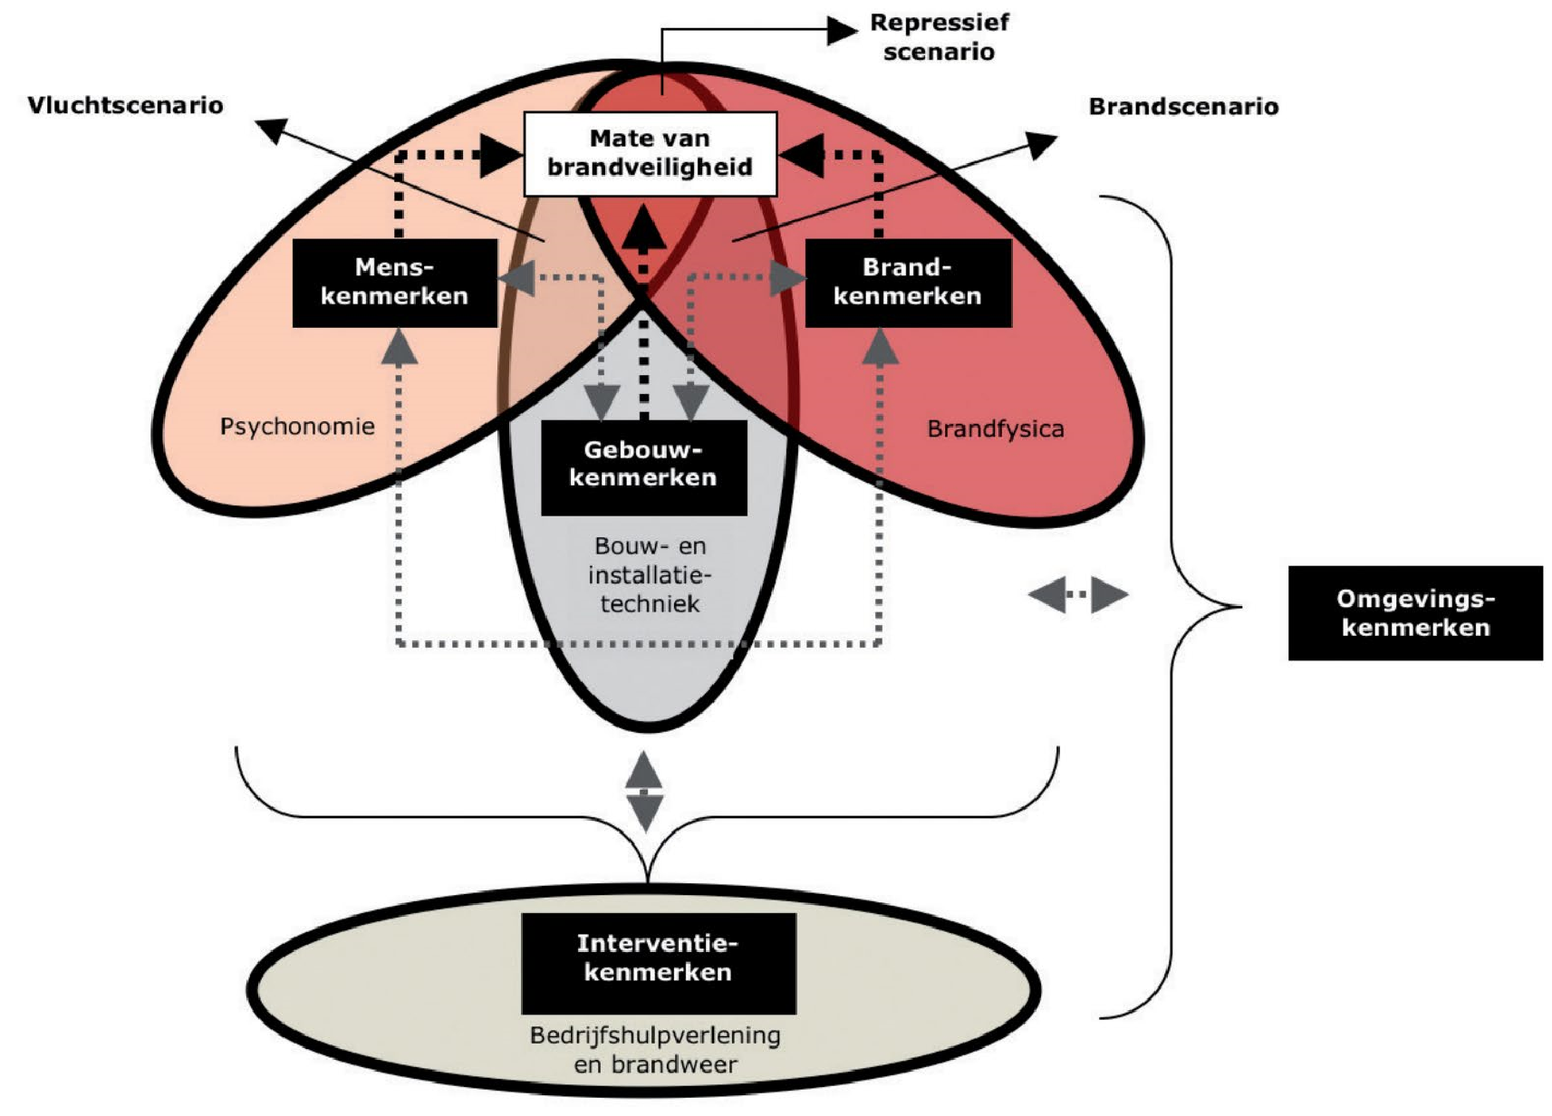

Figure 1.1 The characteristic scheme

1.1 The fire
The following fire characteristics are important when determining the fire safety risks:
- the risk of a fire
- the course of the fire (general and with specific risks per type of vehicle)
- of verbrandingsproducten.

Vehicles are often the object of origin and are the fuel of fires in parking garages. As a result of the energy transition, the number of vehicles running on alternative fuels is increasing. Of course, this increase also has consequences for parking garages, where such vehicles will increasingly be found. In order to provide insight into differences between types of powered vehicles, the following subdivision is used: 1. conventional vehicles (CV)
- electrically powered vehicles (EV)
- vehicles with an alternative energy supply (UAE), such as hydrogen, CNG and LPG.

In the paragraphs below, the fire characteristics in a parking garage are explained in more detail.

1.1.1 Risk of fire
Fires in parking garages can occur due to multiple causes. This may include , for example, arson, a defect in a vehicle or a fire in a (different) object in the vicinity of a vehicle. Statistical data of fires in garages are not or hardly available, so the actual probability of a fire in parking garages is unknown (Institute for Physical Use Safety, 2020a; Van Staalen, 2020). However, the risk of a fire occurring is estimated to be low . For example, in the period between 2006 and 2015, there were only an average of about five registered fires in parking garages per year (Ministry of the Interior and Kingdom Relations). , BZK, 2020). The cause of these fires is not always known.

The risk of fire from causes except for the drive (such as arson) does not seem to be different for EV and UAE than for CV (Institute for Physical Safety, 2020b; Hilster, 2020; Van Straalen, 2020). In the case of causes elevated to the drive, however, that chance may be different. Although various studies indicate that based on the current data there are no reasons to believe that the risk of fire in EV is higher than in CV, this is still the case. not sure (Instituut Physical Safety, 2020a; Hilster, 2020). Statistical data are missing or are only very limited. In addition, some of the above assumptions seem to be based solely on ev charging in parking garages (Hilster, 2020; Van Straalen, 2020). Additional causes of fire as a result of parking, charging and aging of electrically powered vehicles can lead to a higher risk of occurrence (Institute Physical Safety, 2020a).

For UAE , no conclusions can yet be drawn about the risk of a fire occurring in parking garages, due to the limited number of UAE in the Netherlands (Institute for Physical Safety, 2020b; Van Straalen, 2020). In an initial collection of data, however, the probability of an internal fire in hydrogencars seems to be smaller or equal than the chance of a fire in cv. Further research and the building up of sufficient statistical data over the longer term are needed to gain more insight into the probability of the occurrence of fire in parking garages and the possible differences between the different types of vehicles.

1.1.2 Brandverloop
The fire course of car fires in a parking garage often depends on the method and location of ignition, the fire power scenario and specific vehicle parameters. Fires in parking garages are in many cases local in nature. A fire in a car can be limited to that car, but can also spread to surrounding cars. This can cause a travelling fire, which locally has a high fire capacity and a high thermal load on structures (Institute Physical Safety, 2020a; Van Straalen, 2020; Van de Leur, 2015). Due to their local character, such fires are often fuel-controlled. In relatively small garages there is also a risk of a flashover, which means that all cars are involved in the fire. However, the chance of such a fire course is small (Van de Leur, 2015).

In the case of local fires in parking garages, the fire power scenario (the heat release rate) is important. The fire capacity over time determines the thermal load on structural components in the vicinity of the fire. In addition, the fire power scenario shows the fireexpansion and determines the smoke production (Institute for Physical Safety, 2020a; Van de Leur, 2015). In the fire power scenario of cars , there is often a power peak, for example due to the simultaneous involvement of several cars in the fire.

In recent decades , various fire tests have been carried out to determine the power portfolio of cars (Van de Leur, 2015). These studies show that the power scenario is very diverse and depends on many factors, such as the place in the car where the fire starts and the moment of transfer to surrounding cars.
Peak capacities per car of 4 – 10 Megawatts within 5 to 10 minutes and peak capacities above 16 MW in two or more cars are not uncommon. However, the branddevelopment can vary enormously. Due to the increasing use of plastics, there is an increase in the total energy released and therefore an increase in the duration of car fires. Modern vehicles (of all types) therefore have a higher (peak) fire capacity than older models, resulting in more intense and prolonged fires (Institute for Physical Safety, 2020a; Van Straalen, 2020; Van de Leur, 2015).

The above developments apply to all vehicle types. Basically (except for the drive) the total energy present in the different vehicles is comparable. However, there are some specific factors per type of vehicle that influence the fire course and the fire power (scenario) of a car fire in a parking garage. For example, with central heating fuel leaks and the burning of the plastic fuel tank can cause a peak in the fire capacity. In addition, there is the risk of a puddle fire, which can lead to a rapid transfer to surrounding cars (Institute forPhysical Safety, 2020a; Institute for Physical Safety, 2020b; Van de Leur, 2015). The fire behaviour of EV may differ from cv, because this can be accompanied by (repeated) small explosions, flying parts and flames in case of fire in the battery pack t ( Institute for Physical Safety, 2020a).

On the basis of two reports, it seems to be possible to conclude that with the current
IF the fire development is not faster and does not lead to higher (peak) fire capacities
(Institute for Physical Safety, 2020a; Hilster, 2020). However, as the energy storage capacity of EV increases, the peak fire capacity will also increase (at 100 kWh to approximately 8 MW) (Institute for Physical Safety, 2020a). Fires in EV batteries develop more slowly in the beginning than fires in central heating and can also last longer (up to 90 minutes). There is also a risk of re-ignition (after extinguishing) due to the energy present in the battery (Institute for Physical Safety, 2020a; Hilster, 2020; Van Straalen, 2020; Van de Leur, 2015). Together with the deviating fire behaviour, this is expected to increase the chance of a travelling fire (Institute for Physical Safety, 2020a).

Specific risks at UAE are the leakage of gases and the flaring/exploding of these gases. These two risks can affect fire development. As with central heating, the fuel tank can rupture due to heating, which can lead to an explosion. To prevent this, the fuel tanks are equipped with a temperature-controlled pressure valve (TPRD), which ensures that the tank empties in a short time. With hydrogen, this can cause a torch fire. Outflow conditions such as the amount of hydrogen released, the hydrogen pressure, the size of the outflow opening and the outflow direction determine to a large extent the size and direction of the flare or the size of the hydrogen cloud and the hydrogen concentration in that cloud. In theevent that a hydrogen car becomes involved in a fire, is determined, among other things, by the heat intensity (MW/m2) of the fire in the direction of the hydrogen car. The higher the heat intensity, the sooner the TPRD is activated. It cannot be ruled out that the torch that arises when opening the TPRD in a parking garage leads to fire transfer to adjacent cars (Institute for Physical Safety, 2020b).

1.1.3 Verbrandingsproducten
Due to the increase in the use of plastics, the smoke production from fires in parking garages has also increased. Even with a limited fire size, a large amount of smoke is produced that quickly spreads through the garage. Even if the wicked separation structures meet the performance requirements of the Building Decree 2012, there is still a chance that the smoke will spread through openings (residual risks as a result of: opening of doors, cracks and seams, penetrations, openings in the façade and ventilation ducts) further spread. The large amount of smoke and the spread pose a risk to the buildings above and the environment (Institute for Physical Safety, 2020a).

This smoke contains toxic gases; these are comparable for the different vehicle types. However, there is a greater smoke production in case of fire in modern vehicles, which also increases the amount of flammable and toxic gases. The composition of the gases released during fire in EV is also different from that of fire in central heating: burning EV produces more hydrogen fluoride (HF) (up to 1.8 to 2.5 times so much) (Institute for Physical Safety, 2020a; Hilster, 2020). However, this HF may be released over a much longer period of time – even after re-ignition of the accu – so that there may not be a higher concentrations, but of a longer period that toxic and flammable gases are released (Van Straalen, 2020).

1.2 The building
The following building characteristics are important in determining the safety risks:
- size / geometry
- Constructions
- location
- amenities.

1.2.1 Size and geometry
An increasing size (surface area) of a parking garage increases the risk of a fire occurring and therefore also the chance of a travelling fire (Instituut Fysieke Veiligheid, 2020a), see also paragraph 1.1.2. Such a travelling fire can lead to a very long-term (local) moving fire (up to 10 hours) (Van de Leur, 2015). The risk of a prolonged fire increases as the surroundings of the garage increase. On the other hand , casuistry shows that fires in garages usually do not extend to the entire size of that garage, but are limited to a (large) part of it ( Van de Leur, 2015). The size of the garage is therefore not directly equal to the expected fire size, but counts as a risk-increasing factor for the chance of the occurrence of a fire and the likelihood of a prolonged fire. The travelling fire and burning time determine the thermal load on the structure, see section 1.2.2.

An increasing size of a parking garage also increases the risk of casualties: after all, more people can be present (Van de Leur, 2015). This is certainly the case with parking garages with peakcirculation in use (under shopping centers, stadiums and event halls). We are not aware of any cases in which there have been casualties as a result of a fire in a parking garage.

Another building characteristic that influences the brandcenar io is the openness of the parking garage. Openness refers to permanent openings in the facades (and/or roof) of the parking garage. Depending on the openness and presence in the facades, heat and smoke can flow out of the garage and oxygen can flow in at the same time. In open parking garages, the course of fire and smoke spread are therefore influenced by weather influences (temperature and wind pressure). Especially in parking garages of large size and / or with several floors that are vertically connected to each other (for example by ramps and voids) there can be are of rapid fire spread. With open parking garages, there may also be fire spread to the building parts above. However, the removal of heat and smoke can also have a significant effect on the heat build-up in the garage (Institute for Physical Safety, 2020a; Van de Leur, 2015).

In closed parking garages, the course of fire and smoke spread are not or hardly affected by weather influences. As a result, there may be (locally) a faster heat development. In addition, the smoke from a local fire spreads quickly over the entire garage in the absence of facilities that can help prevent this (Institute for Physical Safety, 2020a). These provisions are explained in section 1.2.4. The degree of openness also influences firefighting, see section 1.3.

The shape and internal height of the parking garage are also building characteristics that have an influence. The shape of the parking garage can influence the speed of a travelling fire and of the smoke spread, for example by the location of walls and other structures (such as separation). - and supporting structures), carriageways and parking spaces. These components can slow down the spread of fire and smoke or, on the contrary, enable it in multiple directions . In addition, the shape can influence the application possibilities and effectiveness of facilities such as (fire) ventilation. For example, fire ventilation is easier to apply in narrow, elongated (tunnel-shaped) garages than in square garages, see also paragraaf 1.2.4. In principle, the risk of fire spreading through the smoke layer increases as the internal height of the garage decreases. In addition, the local thermal load on the structure is higher and the height can be limiting for applying v oorzieningen under the ceiling (such as applying of ventilation devices or an automatic extinguishing system). In addition, the lower the parking garage, the sooner it becomes filled with smoke, and the shorter the available escape time becomes.

A specific category of garages are (semi) automatic parking garages. In (semi) automatic parking garages, cars are parked closer to or above each other by the parking system than in non-automatic parking garages. In these garages, there is a high risk of faster fire spread and heating of structures (Institute for Physical Safety, 2020a).

1.2.2 Constructions
With an increasing risk of a travelling fire, the chance that the construction of the parking garage (the enclosure) is locally loaded with a lot of heat (Institute physical Safety, 2020a). The structure is loaded differently than what it was calculated or tested for. Fire-resistant structures are tested on the basis of a post-flashover fire. The temperaturerises sharply in the first few minutes , after which there are high temperatures that gradually increase (for example, to 1050 ⁰C after 120 minutes). In reality, however, there is a locally high to very high thermal load (due to a combination of convective and radiant heat) that can be locally higher. than the prescribed temperature-time curve for testing. On the other hand, this load is very local and moves through the garage in several directions during a travelling fire.

It isunclear whether the thermal load according to a post-flashover fire is comparable to the thermal load of a travelling fire (Institute for Physical Safety, 2020a; Van de Leur, 2015). A comparison may not be possible, because the (sear) high local thermal load leads to a different thermal and mechanical response of structures – and can therefore result in a different collapse behaviour of the structures. The long burning time (up to 10 hours) with the associated long-term load in combination with the local (very) high thermal load due to a fire in several vehicles , creates an increasing risk of damage or collapse of structures. This is also the case if these structures have a fire resistance with regard to the separating function and/or load-bearing function (Institute for Physical Safety, 2020a; Van de Leur, 2015).

In the event of prolonged fires, there is therefore often considerable damage. Examples are splash damage from concrete, partial or local collapse of structures and smoke damage in both the garage, the overlying and adjacent buildings and in the environment (Institute Physical Safety, 2020a; Van de Leur, 2015).

1.2.3 Location and overlying buildings
The location of a parking garage (above ground or underground) has a particular influence on the combatability of the fire (Institute for Physical Safety, 2020a), see section 1.3.
In addition, a location next to other building parts in the area can be a risk factor.
For the environment, see further section 1.5.

A fire in a parking garage also poses a threat to buildings above. In buildings where people sleep, there is an increased risk of casualties. This also applies to buildings in which persons who are less self-reliant reside, and in certain cases also to buildings in which a large number of people can be present. and where there is a relatively long evacuation time (e.g. stadiums) (Institute for Physical Safety, 2020a).

The number of floors of the buildings above the parking garage also determines the time that those present in those buildings need to be able to escape. In other words: the more floors, the longer the flight time is and the greater the effects of a possible fire can be. In addition, there is the risk of smoke spreading to the escape routes, which leads to an increasing risk of victims and an increasing risk to the construction (Institute for Physical Safety, 2020a).

1.2.4 Provisions
Depending on the size of the parking garage, different fire safety facilities may be available. Parking garages with a limited size (smaller than 1,000 m² for new construction) are often designed according to the minimum performance requirements of the Building Decree 2012 and often only have effect-limiting devices such as fire-resistant support and separation structures. Parking garages with eand larger size must be equipped with facilities with an equivalent degree of fire safety as intended by the regulations of the Building Decree 2012. Often, due to safety risks (including for firefighting), there is no boxingand for dividing a garage with a large size into several small compartments. (Institute for Physical Safety, 2020a; Van de Leur, 2015). Ventilation or smoke control is a widely used facility and has all kinds of manifestations, suchas:
> natural ventilation through facades and/or roof openings
> mechanical ventilation (RWA) for making the garage smoke-free after extinguishing
> mechanical ventilation to create a view of the fire during a fire brigade deployment.

Smoke control often has the goal of enabling an effective fire brigade deployment in the parking garage. Smoke control is an effect-limiting device: the facility does not extinguish the fire, but only ensures the removal of smoke and heat. The facility is often designed for a fire of up to 3 cars and extinguishing by the fire brigade. With a faster fire spread and no extinguishing (larger fire), smoke control is usually no longer effective: it is insufficient to c re-establish visibility of the fire and heating of limit constructions (Institute for Physical Safety, 2020a; Van de Leur, 2015).
In addition, effective smoke control due to, for example, the shape of the parking garage is not always feasible. Due to facilities for smoke control, smoke can in some cases spread faster in the garage, the buildings above and the environment. After all, smoke control forces smoke to be pulled through the garage or (mechanically) discharged to the adjacent site. The question is therefore whether only an equivalent degree of safety can be achieved with smoke control (Institute for Physical Safety, 2020a) (Van de Leur, 2015).

Automatic extinguishing systems are a much less frequently used facility in parking garages. Such an installation is source-limiting, because it tackles the fire and/or prevents fire spread. This is discussed in more detail in Chapter 2. There may also be various other facilities available, such as dry extinguishing pipes, smoke locks for stairwells, fire-resistant screens, fire alarm and evacuation alarm systems, et cetera. These facilities can each have a (positive) effect on fire safety in a package of measures. They often complement the basis of fire-resistant separation and supporting structures, smoke control and automatic extinguishing systems. These additional provisions are not discussed one vein.

1.3 The intervention
Until recently, the fire safety of parking garages was largely based on an offensive indoor deployment of the fire brigade in the parking garage, (possibly) supported by smoke control measures. Also in the policy of the fire brigade this was the standard firefighting method as long as it could be carried out safely. In the last decade, however, this principle has come under increasing pressure, partly due to practical cases, where an effective offensive indoor deployment is not possible. pale. As described in section 1.1.2, there is an increasing use of plastics in vehicles, leading to faster fire spread and higher fire capacities in fires in parking garages, which make them more difficult to combat (Institute for Physical Safety, 2020a; Van de Leur, 2015).

1.3.1 No offensive inside bet
In addition, there are also developments within the fire brigade in the field of firefighting; no longer is the offensive inner effort the starting point. The fire brigade uses a number of basic principles in which the tactics and objective are ordered according to the quadrant model (Fire Academy, 2020). The standard starting point of the basic principles is an offensive lootand deployment, so firefighting from the outside. This also applies to the fight against fires in parking garages, especially since an offensive indoor deployment in a parking garage is generally not safely possible. The exact location of the fire is often not known and / or the source of the fire cannot be reached safely and / or the available cooling capacity is insufficient to effectively prevent the fire can fight. Moreover, due to the smoke development, the fire is not or hardly visible with a warme-image camera.

This does not mean that no fire brigade deployment can take place at all, but this will often be limited to an external deployment or defensive deployment where the emphasis is on the limiting fire spread and smoke spread aftersurrounding and overlying buildings (Institute for Physical Safety, 2020a).

The above developments are still separate from other types of/additional risks for the fire brigade with regard to fighting fires in which vehicles running on alternative fuels are involved. These risks include (Institute for Physical Safety, 2020a; Van de Leur, 2015):
> | the likelihood of explosions and flare fires and their effect on firefighters
> | the risk of a different fire course and a longer burning time.
> | the impact of specific toxic gases, such as HF
> | risks of re-ignition and long-term cooling of battery packs
> | the dangers of high voltage.

These risks put even more pressure on the principle of an offensive inside deployment. At the same time, the demand for help for the fire brigade is increasing, which means that not only the risks of a fire brigade deployment aimed at extinguishing are increasing (including for the firefighters), but also the risks of a fire brigade deployment aimed at rescue, for example of people who are located in buildings located above the parking garage.

On the basis of the factors mentioned above, it must therefore be concluded that the starting point must be that an offensive indoor deployment in the parking garage is not possible in advance – certainly with the an eye on the future, in which there are many more vehicles that run on alternative fuels. In other words: the fire safety of parking garages should no longer depend on the deployment of the fire brigade.

1.3.2 Other factors affecting the deployment of firefighters
There are building characteristics that can have a beneficial effect on the actions of the fire brigade.
> | For example, an open above-ground garage is clearer than an underground car park and can therefore increase the accessibility of the fire for fire control. The removal of smoke and heat through openings can also contribute to this (although this can also have adverse effects, see section 1.2.1).
> | Underground garages are usually mechanically ventilated. Depending on the type and design of the ventilation (smoke control), a fire brigade deployment can be influenced by this. However, as indicated in section 1.2.4, the reliability of this device has decreased due to faster fire spreading and no extinguishing (larger fire) (stark).

In addition, vehicles on alternative fuels also provide a different working method during firefighting. The document Fire safety of parking garages with electrically powered vehicles (Institute for Physical Safety, 2020a) offers practical tools for this.

Specific attention should be paid to (semi) automatic parking garages. In view of the implementation and the risks (see section 1.2.1), an automatic extinguishing system seems to be the only logical option. See also chapter 2.

1.4 Man
The risk of victims in parking garages seems limited, because there will often be no question of a high (long-term) occupancy. This does not alter the fact that there are indeed situations conceivable in which there is a higher chance of victims, for example caused by peak moments in use ( shopping centres, stadiums and events) or by the presence of less self-reliant persons (hospitals).

The shape and geometry of a parking garage can also have a negative influence on the discovery and familiarity with escape routes, especially if these escape routes are not the same as the usual access routes.

In addition, user functions in overlying or adjacent buildings can be risk-increasing. In buildings where people sleep (especially in residential buildings) there is an increased risk of casualties due to the collapse of structures and / or smoke spread. This also applies to buildings in which there are persons with reduced self-reliance and to buildings where a large number of people can be present at the same time and where there is a relatively long evacuation time
(e.g. stadiums). The risk of casualties in parking buildings without overlying and adjacent buildings is also low.

1.5 The environment
In the event of a fire in a parking garage, there is a risk of fire spreading and smoke spreading to the environment. In particular, the risk of a prolonged fire and a lot of smoke can lead to unacceptable impact on the environment.
(Fire Academy, 2018). This impact can, for example, lead to an evacuation of surrounding buildings.
Although especially open parking garages can have a major impact on the environment in the event of a fire, this risk is also an issue in mechanically ventilated parkhonor garages such as, for example, the smoke extraction has been realized at ground level (indoor garden, squares, et cetera). Due to the risks outlined in the other characteristics, there may be long-term fires that are difficult to extinguish, increasing the risk of impact on the environment.

1.6 Conclusion based on the risks described
On the basis of the preceding paragraphs, it is concluded that the risks in the event of fires in parking garages have increased and that as a result the fire safety of parking garages has decreased. This includes the following:
> | Regardless of the type of drive, the risk of a travelling fire resulting in a long-term thermal load on the structure has increased due to an increasing use of plastics in modern vehicles.
> | The change in vehicle propulsion (EV and UAE) poses other risks. The risk of fires occurring in EV and UAE seems to be largely comparable to CV. However, additional fire causes can be risk-increasing.
> | In addition, the different fire rate of EV and UAE compared to CV causes other types of / additional risks, such as explosions¹¹, flames, torch fires, the leakage of gases, re-ignition and a different composition of released gases. The increase in EV'senergy storage capacity in the future will also contribute to this.
> | The increased risk of prolonged fires, greater smoke production and the different fire course of EV and UAE can affect the risk of fire spread between vehicles, of fire penetration, the collapse of (supporting) structures and victims (including obstruction of escape routes by smoke).
> | Due to the increase in the use of plastics in modern vehicles and alternative energy supplies, the chance of rapid firefighting of a fire in the parking garage (offensive fire violence) greatly decreased. This is also due to developments in the field of firefighting (basic principles for firefighting): the offensive indoor deployment is no longer the starting point. That is why it must be assumed in advance that an offensive fire brigade deployment in parking garages is not possible. This makes the fight against fire in parking garages comparable to that of fire in compartments of the same size in buildings with other uses, where an offensive interior deployment also is no longer the starting point.
> | The demand for help for the fire brigade is increasing: in addition to the increased risks of a fire brigade deployment aimed at extinguishing (including for the fire brigade personnel), the risks of a fire brigade effort aimed at rescue (both for users and weatherpersonnel).

In addition to these increased fire safety risks in parking garages , the following applies in general :
> Specific building characteristics such as the size and geometry, location and overlying buildings and facilities can increase or decrease fire safety risks in parking garages.
> Sleeping persons, less self-reliant persons or large numbers of people living above, next to, below or in the vicinity of parking garages run additional risks (e.g.
obstruction of escape routes by smoke) in the event of a (long-term) fire in these garages.

It is clear that the fire safety of parking garages has decreased in recent years. On the basis of the above points and in view of the future development in which the number of alternatively powered vehicles will increase,12 additional provisions are therefore necessary to improve the reduce fire safety of parking garages to the minimum level and guarantee them for the future.

- Increase in explosiveness
- It is expected that from 2030 there will be approximately 1.9 million electric cars and approximately 70,000 hydrogen-powered cars.

2 Automatic blous installation
Chapter 1 deals with a number of fire safety risks in parking garages. This shows that additional provisions are necessary to maintain and maintain fire safety. These risks have been translated into a description of the risky situation that must be prevented, see section 2.1. This description was then translated into a purpose and sub-goals to assess whether this can be met with an automatic extinguishing system (paragraph 2.2). Section 2.3 assesses the impact of applying anatomatic extinguishing system for each fire safety risk. In addition, a comparison is made with two other measures, based on:
- an improved fire brigade deployment in the parking garage
- an upgrade of the separation and supporting structures of the parking garage.
Paragraph 2.4 presents a tabular summary of the equation.

2.1 Preventing a risky situation
In this study, the risky situation to be prevented is defined as follows:

A parking garage in which an uncontrollable fire can occur that leads to unacceptable risks of collapse, fire spread and/or smoke spread, and therefore op victims (civilians and aid workers).

An uncontrollable fire in a parking garage is a prolonged, intense, difficult to combat fire (travelling fire) that can spread over a large area (large number of cars). This travelling fire results in a long-term (local) thermal load on the supporting and separating structure of the garage. Although the thermal load always takes place locally, large parts of the structure are confronted with this possibly very high thermal load due to the long-term fire scenario. As the size (m²) of the thermally loaded structure increases, so does the risk of collapse, fire spread, smoke spread and casualties. Risk of collapse, fire spread and smoke spread to other and surrounding building parts pose a threat to escape and attack routes. People present can get stuck in buildings above and must therefore be saved. As a result, the demand for help for the fire increases considerably again. In addition to the increased risks of a fire brigade deployment aimed at extinguishing ( including for the fire brigade personnel), the risks of a fire brigade deployment aimed at rescue (both for users and firefighters). The risksof such a scenario are unacceptable and should be avoided as much as possible.

2.2 Purpose and sub-goals
In order to prevent a risky situation, additional provisions are necessary. After all, the current provisions do not sufficiently prevent such a situation. The aim must therefore be to strive for a manageable fire or a situation in which there are acceptable risks that are also future-proof. A 'manageable fire' in a parking garage is understood to mean a non-intense fire, which poses an acceptable risk to buildings above, the environment and emergency services. In view of the risks described , the fire must be limited to a small area.

In concrete terms, this means that a manageable fire is (long-term) independently limited to a small number of cars (local fire); a travelling fire is therefore prevented. Such a local fire results in a short-term (local) limited thermal load on the supporting and dividing structure of the garage. Because the size (m²) of the structure that is loaded remains limited, the risk of collapse, fire spread and smoke spread to other building parts and the surroundings. This also reduces the risk of slaughter orfers. Preventing the risk of collapse, limiting the risk of fire spread and spreading smoke to surrounding building parts and the environment increase the chance that escape and attack routes remain intact. The chance that people present can even flee and the demand for help for the fire brigade (extinguishing and rescue) decreases. In addition, it increases the chance that the fire brigade can make an effective deployment and keep the situation manageable.

The above definition of a manageable situation leads to the following sub-goals : > the risk of collapse
> limiting the risk of fire spread and smoke spread to other building parts and the environment
> limiting the risk of casualties.

As described, additional provisions must be aimed at preventing a travelling fire, in other words: the fire must be limited to a small area. This means that the focus of facilities is shifting from effect-limiting provisions to source-limiting provisions. An automatic extinguishing system that mainly tackles the source and thus also limits the effects, is a logical provision, partly because the other source-limiting measures (limiting it) of the risk of smoke and limiting smoke production) must be sought in the design of the car and we have no influence on that.

2.3 The influence of an automatic extinguishing system and a comparison with other facilities
An automatic extinguishing system is a source-limiting device that focuses on keeping the fire limited. The fire is often not extinguished directly, but locally controlled into one or a few cars. In addition, the facility focuses on preventing fire spread to surrounding cars.

Because sprinkler systems in parking garages are the most common and have a high reliability, in the comparisons we make with other concepts, the term 'sprinkler system' is used in place of 'automatic extinguishing system'. The sprinkler system is an additional facility on top of the minimum required facilities from the Building Decree 2012 (BB 2012).

This section compares this provision (including the minimum requirements) with two other concepts of provisioning. Because the variety of facilities in these concepts can be large, the comparison focuses on the most essential parts related to parking garages. The concepts are based on the following components:

Upgrading of the separation and supporting structures:
> | higher resistance to fire penetration and transhipment (WBDBO) (30/60 minutes higher) than required by the Building Decree 2012
> | higher resistance (30/60 minutes higher) with regard to collapse than required by the Building Decree 2012
> | fire-resistant separations without technical installation
> | fire-resistant separation between parking garage and superstructure (extra fire separation in the stairwell)
> | when activating the fire alarm system in the parking garage, ensure good alarm follow-up in usertions located on, next to or above the parking garage. In the absence of an evacuation organisation (for example in a residential building), activate the evacuation alarm system with signal transmitters in common traffic areas.

An improved fire brigade deployment:
> | higher resistance (30/60 minutes higher) with regard to collapse than required by the Building Decree 2012
> | fire-resistant separations without technical installation
> | fire-resistant separation between the parking garage and superstructure (extra brandscheiding in the stairwell)
> | stairwells with front portals and dry extinguishing pipe
> | smoke control system according to NEN 6098:2012 with a view of the fire
> | when activating the fire alarm system in the parking garage, ensure good alarm follow-up in user functions located on, next to or above the parking garage. In the absence of an evacuation organisation (for example in a residential building), activate the evacuation alarm system with signal transmitters in common traffic areas.

2.3.1 Travelling fire

Brief overview of the risks
As a result of fire transfer between vehicles, a travelling fire can occur, which locally has a high fire capacity and delivers a high thermal load on structural components (such as columns, beams, walls and floor constructions). The likelihood of a travelling fire has increased due to an increasing use of plastics in vehicles and possibly also due to an increase in EVs and UAEs in parking garages.
At the same time, the possibility of a rapid fight against a fire in eand parking garage (offensive fire brigade deployment) has decreased sharply. The starting point for parking garages is that an offensive fire brigade deployment in the parking garage is not possible.

The influence of a sprinkler system
With the application of a sprinklerinstallation, the risks at the source are combated, increasing the chance of a 'controllable fire '. In the presence of a sprinkler system, there is a good chance that the fire will be limited to one car. The sprinkler system cools the adjacent cars, so that the chance of expansion to these cars is limited. This is expected to apply to all vehicle types:
> EV: the sprinkler system will not extinguish the battery fire, but it will ensure that the risk of fire spreading the battery to other vehicles is limited, as long as the sprinkler works.
> UAE: UAE is also expected to reduce the risk of fire spreading to adjacent vehicles in the presence of a sprinkler system than in a situation zunder sprinkler system.

Comparison with other fire concepts
By using a sprinkler system, there is a good chance that the fire will be limited to one car (or possibly a few cars in the event of a torch fire that leads to firespillage to a other car). On the other hand, the two other fire concepts ('improved fire brigade deployment' and 'upgrading of the separation and supporting structure') do not limit the possibility of a travelling car fire or only very limited. These concepts are aimed in particular at limiting the effects of a fire. Application of the concept of 'improved fire brigade deployment' aims to increase the chance of an offensive fire brigade deployment, so that the fire brigade can intervene in the event of a travelling fire. However, due to the failure probability of smoke control in this concept, it must be taken into account in practice that its effect is limited. In addition, this concept deviates from the basic starting point for a fire brigade deployment, namely that the fire brigade in general will make a non-offensive indoor deployment. The fire concept 'upgrading the separation and support structure' only focuses on limiting the effects of a travelling fire.

2.3.2 Thermal stress on the structure

Brief overview ofthe risks
A travelling fire in the parking garage results in a long-term (local) thermal load on the supporting and dividing structure of the garage. Although the thermal load always takes place locally, large parts of the structure with this potentially very high thermal load are confronted by the long-term fire scenario .

The influence of a sprinkler system
Section 2.3.1 shows that with the use of a sprinkler system, there is a good chance that the fire will be limited to one or a few cars. This means that the thermal load on the supporting and separating structures also remains local and limited. This greatly reduces the risk of damage or collapse of structures.

Comparison with other fire concepts
Here too, both other concepts ('improved fire brigade deployment' and 'upgrading of the separation and supporting structure') are aimed at limiting the effects of the thermal tax. As indicated in section 2.3.1, the application of smoke control in the concept of 'improved fire brigade deployment' has a (high) probability of failure. There is a real chance that the fire brigade will not be able to intervene in a travelling fire, as a result of which the supporting and separation structures will be subjected to long-term thermal stress. The concept also assumes a higher resistance to collapse than required at least. This increases the reliability of supporting structures in principe and thus reduces the risk of collapse. However, it is unclear what the value of this increase is, because it is not known to what extent the thermal load of a postflashover fire compares. is with that of a travelling fire.

The same applies to the concept of 'upgrading the separation and supporting structure'. The higher resistance with regard to collapse and higher WBDBO than minimally required, increase the reliability of separation and supporting structures and thus reduce the risk on succumbing. Here too, however, it is unclear what the value of this increase is.

2.3.3 Limiting the spread of smoke within the building

Brief overview of the risks
In the event of a prolonged brand in a parking garage , smoke spread to other building parts can occur. This can result in escape routes and attack routes being obstructed. The longer a fire lasts, the greater the chance of smoke spreading and casualties elsewhere in the forest.

The influence of a sprinkler system
By early intervention of a sprinkler system, smoke production and smoke spread are also indirectly limited (although there will still be smoke). The smoke production and thus the chance op smoke spread to buildings above will decrease sharply compared to a travelling fire. This increases the chance that people present can flee independently and the request for help for the fire brigade with regard to rescue and evacuationis smaller. The risk of victims is therefore greatly reduced.

Comparison with other fire concepts
With both other concepts ('improved fire brigade deployment' and 'upgrading of the separation and supporting structure'), smoke production is not limited. Both concepts are intended to prevent the spread of smoke and thus limit the effect . In the concept of 'improved fire brigade deployment', smoke spread to buildings above is limited by removing smoke, limiting penetrations, separating escape routes and stairwells to be equipped with smoke locks. These measures greatly reduce the risk of smoke spreading to buildings above.

In the concept of 'upgrading the separation and supporting structure', smoke spread to buildings above is limited by limiting penetrations and separating escape routes. These measures reduce the risk of smoke spreading to buildings lying in the oven. However, the reliability of this is less high than with the concept of 'improved fire brigade deployment'.

The following applies to both concepts: if there are user functions on, next to or above the parking garage that are also equipped with an evacuation alarm system, then activation of the fire alarm system in the parking garage ensures proper alarm follow-up in those adjacent user functions. With a good alarm follow-up, it is more likely that personen can flee from the adjacent use function. A company emergency response organization can ensure a good alarm follow-up, but in a standard residential building there is no company emergency response organization. In this case , the concepts simply use an evacuation alarm system with signal transmitters in the common traffic areas of the residential building. However, a quick alarm does not automatically ensure a good alarm follow-up. Whether there is actually a flight depends, among other things, on the degree of self-reliance of the people present.

2.3.4 Smoke spread to the environment

Brief overview of the risks
In the event of a prolonged fire in a parking garage, smoke can spread to the environment. Such smokespread can have a social impact and cause (smoke) nuisance in the environment and other buildings in the vicinity of the parking garage. This in turn can lead to a greater demand for help with regard to rescue and evacuation for the fire brigade.

The influence of a sprinkler system
Section 2.3.3 shows that smoke production and thus the spread of smoke to the buildings above is limited by the use of a sprinkler system.
This also reduces the risk of smoke spreading to the environment.

Comparison with other fire concepts
In the concept of 'improved fire brigade deployment', the smoke is removed by a smoke control system. This can have a positive or negative effect on the spread of smoke in the area, depending on the position and execution of the blow-out device(s).

Application of the concept of 'upgrading the separation and supporting structure' has no positive effect on the spread of smoke to the environment.

2.3.5 The deployment possibilities ofthe fire brigade

Brief overview of the risks
Due to recent and future developments in the field of vehicles and developments within the fire brigade, the possibilities for rapid firefighting of a fire in the parking garage (offensive) ve fire brigade deployment) greatly decreased. The starting point for parking garages must be that an offensive fire brigade deployment is not possible in advance. The possibilities for an offensive outdoor deployment are also very limited, due to the location and accessibility of the fire source and the required cooling capacity to be able to handle the fire. extinguish.

The influence of a sprinkler system
With the application of a sprinkler system, the fire is tackled 'at the source' and the fire is kept small. This increases the chance of effective (indoor) deployment by the fire brigade. The sprinkler system also gives the fire brigade more time to get the situation under control and, if necessary, to offer help to people in or around the parking garage. . Although there are still risks that may affect firefighting (flare fires, explosions and limited zicht), the possibilities for effective (indoor) commitment increased.

Comparison with other fire concepts
The concept of 'improved fire brigade deployment' aims, as the name implies, to increase the chance of a fire brigade deployment in the garage. However, the failure rate in the field of smoke control in this concept is high, because it assumes a limited fire. In addition, this concept deviates from the starting point for a fire brigade deployment. As a result, this concept seems to provide an improvement for the fire brigade deployment, especially in theory.

With the application of the concept 'upgrading the separation and supporting structure', the chance of a fire brigade deployment is not (immediately) increased. For both concepts, however, the provisions aimed at limiting the collapse of structures and limiting smoke spread do have a positive effect on the fire brigade deployment . However, this mainly concerns the request for help with regard to rescue and evacuation from the buildings above and the environment and not the fire brigade deployment in the garage itself.

2.4 Summary table
Table 2.1 below summarises the comparison in section 2.3. The left column shows the risks discussed in sections 2.3.1 to 2.3.5. The top row shows the three concepten. The table then values the effect of this measure for each risk by means of the following scale:

> | ++: very large effect
> | +: great effect
> | +/-: limited effect
> | -: hardly any effect
> | --: no effect

Table 2.1 Summary table
 | Improved firefighting deployment | Upgrading construction | Automatic  blusinstallatie (sprinkler)
2.3.1 Travelling fire | - | -- | ++
2.3.2 Thermal load construction | +/- | + | ++
2.3.3 Smoke spread within | + | +/- | +
2.3.4 Smoke spreading environment | +/- | -- | +
2.3.5 Deployment possibilities for the fire brigade | +/- | -- | +

The comparison and the table show that a sprinkler system most limits the fire safety risks and therefore the chance of casualties. This provision (greatly) limits almost all risks, in contrast to the other conctions which limit only a few specific risks. However, the mitigation of a number of risks is assessed as 'limited', 'hardly' or 'none'. The reason for this is that the concepts assessed are based on a combination of effect-limiting measures that is compared with a source limiting device in the form of a sprinkler system, which prevents a travelling fire as much as possible.

In both other concepts, good alarm follow-up plays a role in on- , next- or above-lying user functions. This reduces the chance of victims if there is actually an alarm follow-up. In buildings without an evacuation organization, alarm follow-up after alarm is not guaranteed, because this is dependent on the self-reliance of persons, among other things. Again , these provisions do not focus on limiting the source.

In view of the future developments of the vehicles and all the uncertainties mentioned, it can be considered to make more provisions in addition to an automatic extinguishing system. The concepts assessed in this report contain meaningful facilities that can serve as a supplement to a sprinkler system.

3 Substantiation criteria 'sleeping buildings'
Chapters 1 and 2 show that with a sprinkler system: > a fire in a parking garage can remain 'manageable' > the following risks are limited:
- the risk of damage and collapse of the structure
- the risk of fire spread between the vehicles andto the structure
- the risk of smoke spreading to other building parts and the environment – the risk of casualties
> the chance that the fire brigade can make an effective deployment increases.

In view of the fire safety risks considered in Chapter 1 and the comparison of a sprinkler system with two other fire safety concepts given in Chapter 2, theapplication of a sprinkler system in all existing and new parking garages for the hand.

In this chapter , a substantive basis is given for the choice of the
Ministry of the Interior and Kingdom Relations to require a sprinkler system for newly constructed sleeping buildings > 13 meters and for parking garages > 1,000 m². The use of a sprinkler system is mandatory if one of these limit values is exceeded. The substantiation also includes other possible differences between buildings when it comes to fire safety, such as the presence of a single or second escape route.

A concise field study was carried out for the substantiation ( consisting of obtaining information from a number of safety regions), so that concrete proposals can be given about concrete projects. This applies in particular to the category where the highest floor of a 'sleeping building' is ≤ 13 m above the measuring level, but where the usable area of the below located parking garage > 1,000 m².

Section 3.1 contains the text of the annotation that the Ministry of the Interior and Kingdom Relations has given to the Building Regulations Consultation Platform (OPB). Section 3.2 shows the results of the field survey conducted, and section 3.3 provides the substantive analysis.

3.1 Current annotation
The Ministry of the Interior and Kingdom Relations has made the following proposal to the OPB for draft regulations for the application of a sprinkler system in parking garages.

Draft prescription
An other use function for storing motor vehicles is equipped with a fixed fire extinguishing or control system that complies with NEN-EN 12845 and NEN 1073, if this is a use function located under a residential function, a meeting function for children under 4 years of age, cell function, accommodation function, or health care function with bed area, and:
- the above-level use function has a floor intended for persons which is at least 13 m above the measurement level, or
- the other use of motor vehicle storage has a usable area of more than 1,000 m2.

Explanation
Article 4.223a applies to (new) parking garages under a residential function,
meeting function for children under 4 years of age, cell function, accommodation function or health care function with bed area.
The parking garage must be equipped with a fixed fire extinguishing or control system that complies with NEN-EN 12845 and NEN 1073. This is a sprinkler or a water mistsystem. This requirement applies if the above-level use function has a floor intended for persons which is at least 13 above the measuring level. This applies regardless of the size of the usable area of the parking garage. This requirement also applies to a usable area smaller than 1,000 m². For less high-rise buildings, the requirement only applies from a usable area of more than 1,000 m2.

Fire compartments with a usable area of more than 1,000 m2 do not meet the performance requirement of articlel 4.51 (fire compartment: size) and these large fire compartments will be used take measures on the basis of equivalence to comply with Article 4.51. On the basis of Article 4.223a , this will always be a fire extinguishing or control system, unless one also opts for an equivalent for this article. solution.

Article 6.36 applies to the installations referred to in Article 4.223a. This means that these installations must be provided with a valid inspection certificate issued on the basis of the CCV Fire Protection Inspection Scheme.

In practicalterms, this means that an automatic extinguishing system becomes mandatory in the following cases, see Table 3.1:

Table 3.1 Obligation to use a sprinkler for different categories
Category Surface Area Highest floor residential area parking garage (m²) building (m) | Sprinkler?
A < 1,000 < 13 | No
B < 1.000 > 13 | And
C > 1.000 < 13 | And
D > 1.000 > 13 | And

Schematically, this table looks as shown in Figure 3.1.

Figure 3.1 Sprinkler mandatory in category B, C and D

3.2 Field research
In order to answer research question 3, a concise field study was conducted among a number of safetycriteria. At the request of the Ministry of the Interior and Kingdom Relations, safety regions were asked about concrete projects in which the highest floor of a 'sleeping building' < 13 m above the measurement level, but where the usable area of the parking garage below is > 1,000 m² (category C). The results are set out in Annex 1. The field study has resulted in five projects that can be used for this research, of which projects 1 and 2 are included in the annex. These come from the Amsterdam Amstelland fire brigade and the Central and West Brabant Safety Region.

3.2.1 Categories C
Several respondents from the field survey indicated that this combination does not often occur in practice. Only two of the proposed projects (projects 1 and 2) therefore fall within the requested criteria: 'sleeping building ≤ 13 m above the measurement level in combination with a parking garage > 1.000 m²'. The assumption is that such relatively small buildings will generally have a parking garage ≤ 1,000 m2. In that case, a sprinkler system is not mandatory according to the annotation of the Ministry of the Interior and Kingdom Relations.

In project 1, there are several 'sleeping buildings' (two residential buildings) above a parking garage. From each building it is possible to flee via two stairwells to the adjacent site. One of the two stairwells of each residential building continues into the basement. In project 2, there is one residential building above the parking garage. This residential building is divided into several linked blocks; the residents can only flee to the adjacent site via one escape route. The lift (shaft) of the living area is connected to the parking garage.

3.2.2 Other projects proposed
The other projects proposed by the safety regions have emerged due to the presence of a (semi)automatic parking system:
> | project 3: highest floor sleeping building > 13 m, usable surface parking garage <  1.000 m²
> | project 4: highest floor sleeping building < 13 m, usable surface parking garage <  1.000 m²
> | project 5: highest floor sleeping building > 13 m, usable surface parking garage > 1,000 m2.

The respondents of the Haaglanden Safety Region and the Amsterdam-Amstelland Fire Department indicate that in practice it is increasingly common for parking garages to be equipped with a (semi)automatic parking system. . This seems to be in line with the tendency to discourage car use. At the same time, this solution requires less surface area for a parking garage, because it can fit more cars. Parkinggarages with a (semi)automatic parking system also occur in combination with a sleeping building whose highest floor is > 13 m above the measuring level.

An automatic parking garage has a fully automatic parking system. Through this system, the user parks the car in an entrance area, which he / she then leaves. The user scans his card outside, after which the car is placed in the parking garage completely automatically.

A semi- or semi-automatic parking system makes it possible to park several cars above or next to each other. This creates more parking capacity. Users park their car in and out themselves: a first driver drives his/her car on a platform, the next one raises the system and parks his/her car. her car underneath (Institute for Physical Safety, 2020a).

The respondents of the Haaglanden Safety Region and the Amsterdam-Amstelland Fire Department indicate that such parking systems pose the following risks from a fire safety point of view:
> | The presence of more cars due to 'stacked' parking spaces compared to parking garages without a (semi)automatic parking system. Cars are closer together, resulting in a faster fire spread and the chance that several cars will catch fire at the same time.
> | Due to the risk of falling and clamping, there are more possibilities for the fire brigade to
to act repressively in comparison with parking garages without a (semi)automatic parking system. In addition, in the event of a malfunction of the parking system, the vehicles cannot be taken out.
For this reason, such parking garages (partly on the advice of the fire brigade) are regularly equipped with an automatic extinguishing system (in the form of a water mist system), but that is according to the Building Decree 2012 is not mandatory.

3.3 Analysis

3.3.1 Translation of the targets into measurable limit values
On thebasis of the fire safety risks considered in Chapters 1 and 2 , high-risk parking garages can be described as follows:
> | Car parks above which other buildings are located (particularly risky because of the dangers to the persons present in them: smoke spreading, obstruction of escape routes and the possibility of the collapse of the construction).
> | Parking garages in which alternatively powered cars (electric, hydrogen, CNG) are charged and parked (especially risky because of the different types of risks of fire spread between the vehicles and to the construction). It is expected that alternatively powered vehicles will be present in all parking garages in the future (2030).
> | Car parks in which there is (semi)automatic parking (especially risky because of the close-knit vehicles (faster expansion and locally higher fire capacity), as well as the limited possibilities for firefighting (location, accessibility, cooling capacity).

In view of these risks and with a view to future-proof regulations, this analysis leads to the conclusion that, for parking garages in the 2012 Building Decree, a general obligation to use of a sprinkler system . However, the application of a sprinkler system in the proposed annotation is limited to 'sleep-> 13 metres' and 'parking garages > 1,000^{m2}'. These criteria are further substantiated in the following paragraphs.

3.3.2 Slaapgebouwen > 13 m

Criterion 'sleeping buildings'
It is conceivable that a fire in a parking garage located under a 'sleeping building' is only discovered after some time by people who are present in that building. The result is that it also takes some time before the fire is reacted to and fled. A sprinkler system ensures that a fire in the parking garage remains manageable, so that the chance of an unsafe situation for sleeping people in the buildings above remains limited. . Buildings in which people sleep have the following use functions according to the Building Decree 2012:
> | residential function
> | celfunctie
> | logiesfunctie
> | health care function with bed area
> | meeting function for childcare with children < 4 years.

Limiting the risk of an unsafe situation in a building also applies to all other types of buildings above a parking garage. This could include, for example, buildings with less self-reliant persons, or buildings in which a large number of people may be present and where there is a relatively long evacuation time (e.g. stadiums). In such buildings, the persons present are generally in a non-dormant state and/or there is an evacuation organisation (e.g. emergency response) which has a accompanies any evacuation.
In the case of people who are not sleeping, it is more likely that a fire in a parking garage will be detected at an early stage. In the case of an evacuation organization, help is available to ensure that the evacuation / evacuation takes place smoothly.

In short: the proposed category of 'sleeping buildings' where there is no evacuation organisation and where there are less self-reliant persons is the most urgent category from a safety point of view. . Moreover, this category fits within the user functions defined in the Building Decree 2012, so that they do not have to be adjusted or expanded.

Criterion > 13 m above the measurement level
The higher the building, the greater the effects of a fire. As the building is higher:
> | the flight time increases
> | the effects of a fire on the building may be greater
> | the consequences of smoke spreading to the escape routes may be greater
> | increases the risk of casualties
> | increases the likelihood of damage to the structure from the fire before people have fled.

The walking distance in a stairwell increases as the building height increases. This also increases the time of escape from a building. The chosen limit value of 13 m is also in line with the limit value given in the Building Decree 2012 for the resistance to collapse of a building structure. This fire resistance with regard to collapse must be at least 120 minutes in 'sleeping buildings' in the event that a floor of a residential area > 13 m above the measurement level lies.

3.3.3 Parking garages > 1,000 m²
The surface area criterion of the parking garages concerns the usable area of the parking garage as a whole, not the usable area of a fire compartment in it. This means that, if fire compartments with a usable area ≤ 1,000^{m2} are realized in the parkingfacility, the obligation for an automatic extinguishing system in a parking garage still applies.

The larger the usable area of the parking garage:
> the greater the chance of fire occurring
> the greater the chance of a long-term fire (travelling fire)
> the greater the chance of a long-term high thermal load on the supporting and separation structures of the parking garage.

A sprinkler system reduces the chance of a travelling fire occurring and thus the chance of a long-term high thermal load on the structure in the garage. The surface criterion of 1,000 m2 is in line with the maximum surface area that a fire compartment may have in eand parking garage (Article 2.83, first paragraph, of the Building Decree 2012). The quantification of this surface is not so much about the surface of the fire, but about the greater chance of a fire occurring, with a greater chance of a travelling fire with the described effect as a result.

3.3.4 Combinations of surface area and height

According to the draft regulations in the annotation, the application of an automatic extinguishing system is mandatory for a combination of the following surfaces of a parking garage and the highest floor of a residential area of a sleeping building above it:

Category B: ≤ 1,000 m2 and > 13 m
In this situation, there is a parking garage ≤ 1,000 m2 with a 'sleeping building' above it, of which the highest floor of a residential area is > 13 m above the measurement level. The risks associated with a higher building height (greater flight time, greater effects of a fire) have already been identified. In parking garages ≤ 1,000 m2, there is a smaller chance of a fire (fewer cars), but the effects of this are at least comparable for higher 'sleeping buildings'. . Therefore, from a fire safety point of view and also from the point of view of consistency, there is sufficient reason to apply an automatic extinguishing system in a parking garage ≤ 1,000 m². in the event that there is a 'sleeping building' above the parking garage of which the highest floor of a residential area is > 13 m above the measuring level.

The field research shows that (semi) automatic parking is increasingly being chosen in parking garages. In that case, there are several cars that are close together and the possibilities for firecontrol by the fire brigade are more limited. In practice , these parking garages often appear to be sprayed on the advice of the fire brigade. This shows that they are a risky, urgent category. Respondents from the Haaglanden Safety Region have indicated that the combination of a parking garage > 1,000 m2 in combination with (semi)automatic parking in practice because of cost considerations are not common.

Category C: > 1.000 m ² in ≤ 13 m
In this situation, there is a parking garage > 1,000 m2 with a 'sleeping building' above it, of which the highest floor of a residential area is ≤ 13 m above the measurement level. Two specific situations emerged from the field research :
> | The situation where the 'sleeping building' that is located above the parking garage has only one escape route. For residential buildings, this concerns the so-called 'portico'. In that case, the effects of smoke spread to the single escape route may be greater compared to the situation in which multiple escape routes are present, as well as the probability on victims.
> | The situation in which there are several separate 'sleeping buildings' above the parking garage. In that case , several 'slaap buildings' as well as several people are threatened at the same time by smoke spreading from the parking garage, which also increases the risk of casualties. gets bigger.

The most urgent category is the situation in which the 'sleeping building' has only one escape route that leads through a space that is accessible from the parking garage. In that case, there is a very high probability that this only escape route will be blocked by smoke as a result of a fire in the parking garage and the risks are greater compared to the situation in which there are two escape routes that lead through a space that is accessible from the parking garage.

Category D: > 1.000 m ² in > 13 m
In this situation, there is a parking garage > 1,000 m2 with a 'sleeping building' above it, of which the highest floor of a residential area is > 13 m above the measurement level. This category does not require any further explanation: the justification for this is already given in the other situations.

4 Conclusions

4.1 The answer to research question 1

4.1.1 Research question 1
What are the fire safety risks of parking garages under buildings? Include the various functions of use, the fire safety objectives (limitation of victims, limitation of fire spread), the repressive deployment of the fire brigade and the relevant regulations of the Bbl in which the fire safety objectives are further elaborated in concrete performance requirements (fire compartments with limit values and the like).

4.1.2 Reply
The research concludes that :
> | Due tothe increasing use of plastics in modern vehicles, the risk of a travelling fire with a long-term thermal load on the structure has increased compared to the principles that underlie the regulations for parking garages. In addition, the smoke production from fires in parking garages has also increased: even with a limited fire size, a large amount of smoke is produced with the chance that it will occur quickly spread through the garage and overlying buildings and surroundings. As a result:  - increases the risk of fire penetration, of the collapse of (supporting) structures and of victims  - do sleeping persons, less self-reliant persons or large numbers of people above, next to, below or in the vicinity of parking garages run additional risks (including obstruction of escape routes by smoke).
> | In addition, the different fire behavior of EV and UAE compared to CV causes other types of / additional risks, such as explosions, flames, torch fires, the leakage of gases, re-ignition and a different composition of released gases.
> | Due to the increase in the use of plastics in modern vehicles and alternative energy supplies, there is a chance of rapid firefighting of a fire in the parking garage (an offensive fire brigade deployment). greatly decreased.
> | Specific building characteristics, such as the size and geometry, location and overlying buildings and facilities, can increase or decrease the risk.

4.2 The answer to research question 2

4.2.1 Research question 2
Why is an automatic extinguishing system the right solution to manage these fire safety risks compared to other possible solutions, which can follow from the draft NEN standard for parking garages? Answer this question by making an initial risk comparison against the following two other possible solutions:
- the application of fire ventilation with improved fire brigade deployment
- The application of a burn-out scenario (for example: 'construction with higher fire resistance with regard to collapse').

4.2.2 Reply
With an automatic extinguishing system, a fire is (long-term) independently limited to a small number of cars (local fire), which prevents a travelling fire. This local fire results in a short-term (local) limited thermal load on the supporting structure of the garage. As a result:
> | reduces the risk of collapse, fire spread and smoke spread to other building parts and the environment.
> | reduces the risk of victims
> | increases the chance that people present can flee independently
> | increases the likelihood that flight and attack routes will remain intact.
> | decreases the demand for help for the fire brigade (extinguishing and rescue)
> | increases the chance that the fire brigade can make an effective deployment and keep the situation manageable.

With an automatic extinguishing system, almost all discussed risks are (strongly) limited. This is in contrast to the other concepts which are based on a combination of effect limiting provisions that do not outweigh a source limiting provision in the form of an automatic extinguishing system. The basis for this lies in the fact that, in contrast to the other two concepts, when using an automatic extinguishing system, a travelling fire is prevented as much as possible.

4.3 The answer to research question 3

4.3.1 Research question 3
Provide a substantive justification for the choice to apply the requirement for an automatic extinguishing system to 'sleeping buildings' of which a floor of a residential area > 13 m eater is located above the measurement level. Ditto for parking garages > 1,000 m2. Also include other possible differences between buildings when it comes to fire safety, such as the presence of a single or second escape route.

4.3.2 Reply

Category ie B in D: 'slaapgebouw > 13 m'
The proposed category of 'sleeping buildings' above parking garages where there is no evacuation organisation and/or where less self-reliant persons are present, concerns from a safety point of view the most urgent category. After all: it is conceivable that a fire in a parking garage located under a 'sleeping building' is only discovered after some time by people who are present in that building. As a result , it also takes some time before the fire is started and fled. The walking distance in a stairwell increases as the building height increases. This also increases the time of escape from the building. The higher the building, the greater the effects of a fire (including an increase in the risk of casualties). The limit value of 13 m is in line with the limit value given in the Building Decree 2012 for the fire resistance with regard to collapse of a building structure.

Category C and D: 'parking garage > 1,000 m2'
The morerotten the usable area of the parking garage, the greater the chance of a fire occurring, the greater the chance of a long-term fire (travelling fire) and the greater the chance of a fire long-term high thermal load on the load-bearing and separation structures of the parking garage. The surface criterion of 1,000 m2 is in line with the maximum surface area that a fire compartment may have in a parking garage (Article 2.83, first paragraph, of the Building Decree 2012).

Category B: combination parking garage ≤ 1,000 m² and sleeping building > 13 m
The effects of a fire in a parking garage ≤ 1,000^{m2} are comparable for 'sleeping buildings' > 13 m to the effects of a fire in a parking garage > 1,000 m². However, the effects of a fire increase as the building height increases (longer flight time, greater risk of casualties).

Category C: combination of parking garage > 1,000 m² and sleeping building ≤ 13 m Two specific situations emerged from the field study:
> A 'sleeping building' above a parking garage with one escape route: there is a greater chance of victims due to the unusability of the single escape route (which can be threatened by smoke).
> Above the parking garage are several separate 'sleeping buildings': there is a greater chance of victims in several 'sleeping buildings'.
The most urgent category is the situation where the 'sleeping building' has only one escape route that leads through a space that is accessible from the parking garage. In that case, it is most likely that this only escape route will be covered in smoke as a result of a fire in the parking garage and the risks are greater. compared to the situation in which there are two escape routes that lead through a space that is accessible from the parking garage.

(Half) automatic car parks
The field research shows that in the construction of parking garages, it is increasingly being decided to install a system for (semi) automatic parkingspaces. In that case, there are several cars that are close to each other, so that the possibilities for firefighting by the fire brigade are limited. In practice, however, these parking garages often appear to be sprinkled on the advice of the fireagain. This shows that they are a risky, urgent category.

5 Recommendations
Based on this research, the following recommendations can be made:

> | It is recommended to include in the explanatory notes to the article text in the Bbl the areas of the sprinkler system to be reached, as shown in section 2.2 of this report.
> | With regard to category B (> 1,000 m² and ≤ 13 m): in order to avoid requiring a sprinkler system for every parking garage in this category, it can be considered only for for the most urgent category described in the study: a 'sleeping building' with a narrow escape route that leads through a space that is accessible from the parking garage.
> | The proposed sprinkler system for categories C to D also applies to parking garages with a (semi) automatic parking system. It is recommended to extend the obligation for a sprinkler system to all categories of parking garages where there is a (semi) automatic parking system and above which there is is a 'sleeping building'.

Bibliography
Fire Academy. (2017). Basis for fire safety. The substantiation of fire protection in buildings. Arnhem: IFV.
Fire Academy. (2020). Basic principles of firefighting. Arnhem: IFV.
Fire Academy. (2018). Social impact of branden. Arnhem: IFV.
Hilster, D. L. (2020). Safety and electric passenger cars. Update factsheet 2020.
Delft: CE Delft.
Institute for Physical Safety. (2020a). Fire safety of parking garages with electrically powered vehicles. Arnhem: IFV.
Institute for Physical Safety. (2020b). Safety aspects of hydrogen cars in parking garages - Part 1. Arnhem: IFV.
Li, Y. (2018). Fire and explosion hazards of alternative fuel vehicles in tunnels. RISE.
Ministry of the Interior and Kingdom Relations. (BZK, 2020). Answering questions from Members Beckerman and Laçin (both SP) about fire hazards in parking garages and under homes. Retrieved from letter to Parliament 2020-0000138658: https://www.rijksoverheid.nl/binaries/rijksoverheid/documenten/kamerstukken/2020/03/24/answering-questions-about-fire-danger-in-parking-garages-and-under-homes/answering-questions-about-fire-danger-in-parking-garages-andunder-.pdf.
Van de Leur, P. (2015). Research guideline fire safety parking garages. The Hague:
DGMR.
Van de Leur, P. J. (2020). Phase 1 literature review, research proposals; status: preliminary. DGMR, LBPSight & Royal HaskoningDHV.
Van Straalen, Y. (2020). Risks in parking garages as a result of electric and hydrogen-powered passenger cars - International Inventory. Delft: TNO.

Annex 1: Results of the field study
In order to answer research question 3, a concise field study was conducted among a number of safety regions. Safety regions have already been asked about concrete projects in which the highest floor of a 'sleeping building' is ≤ 13 m above the measurement level, but where the usable area of the parking garage below is > 1,000 m².

The text of the report, which was sent to the safety regions by e-mail via René Schage and Marcel Koene of the Netherlands Fire Brigade, reads as follows:

Commissioned by the Ministry of the Interior and Kingdom Relations, we are currently conducting a study into the application of an automatic extinguishing system in certain types of parking garages. This mainly concerns parking garages that are located under buildings where sleeping people can be present. For a certain category of parking garages, we are looking for practical examples to illustrate the research. Specifically, this concerns parking garages with a usable area > 1,000 m², with a building above it (or. (ge) of which the highest floor of a residence area is ≤13 m above the measurement level. This concerns a parking garage in combination with a residential building (s) above it, health care function, accommodation function or meeting function for children'scare or combinations of that.

Would you like to put this question to the department? As input, a map of the parking garage and a cross-section over the entire building are sufficient. The aim is to find out whether and in what forms the mentioned combination (> 1,000 m² / < 13 m) occurs in practice.

Project 1: 'Residential building with parking garage VR Midden- en West-Brabant'
The project concerns a parking garage with a usable area of approximately 1,200 m2 above which are two residential buildings with a total of 28 apartments. The highest floor of the residential areas of the residential buildings is < 13 m above the measurement level. From each house you can flee via two stairwells to the adjacent site. One of the two stairwells of each residential building loopt through to the basement. According to the draft regulations (in accordance with annotation OPB), an automatic extinguishing system is mandatory for this parking garage (category C:< 13 m; > 1,000 m²).
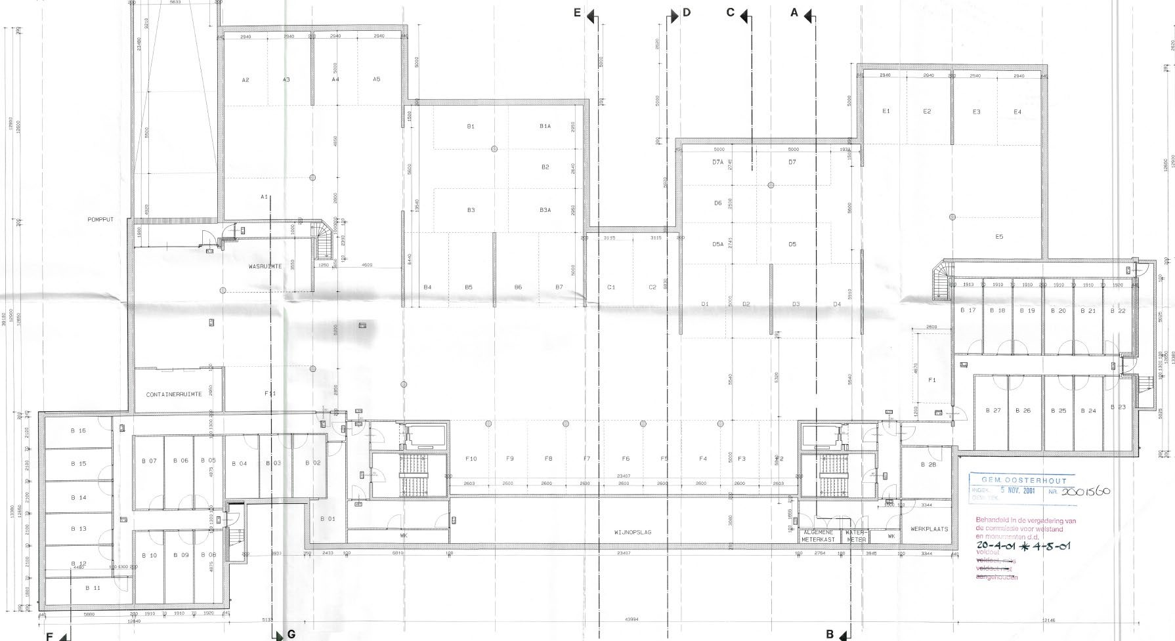

Figure B1.1 Map of the parking garage
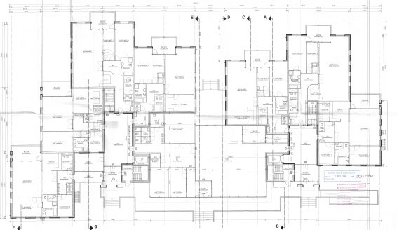

Figure B1.2 Ground floor plan

Project 2: 'Residential building fire brigade Amsterdam Amstelland'
The project concerns a parking garage with a usable area of approximately 3,105 m² above which is a residential building. The highest floor of the residential areas of the residential buildings is 12.4 m above the measurement level. According to the draft regulations (in accordance with annotation OPB), an automatic extinguishing system is mandatory for the parking garage (category C: < 13 m; > 1,000 m²).
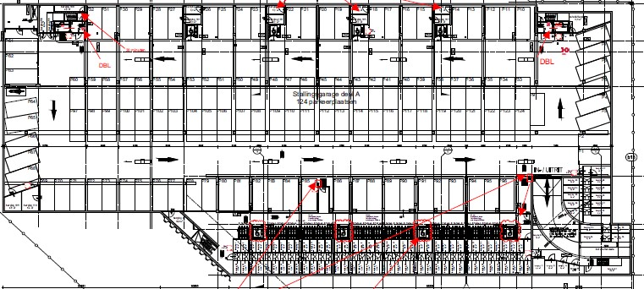

Figure B1.3 Map of the parking garage
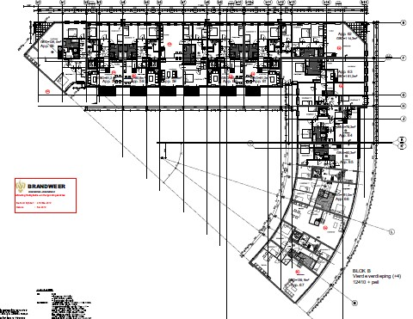

Floor plan 4th floor

It is expected that from 2030 approximately 1.9 million electric cars and approximately 70,000 cars will be driving around on hydrogen.
These are vehicles with a verbranding engine on fossil fuels.
These are both electric vehicles with battery and 'plug in' hybrid vehicles.
These are both combustion engines on CNG and hydrogen, as well as electric cars with hydrogen.
A fire that is spreading in moremoved through the parking garage where a number of cars are always on fire at the same time. Multiple fires can be present simultaneously as the length of time and the number of burned-out cars increase.
Examples of suchlijke branden: Liverpool and Stavanger.
Based on a cellulose-like fuel.
This of course depends on the implementation of the smoke control system.
Examples are De Appelaar (2010) in Haarlem, Markenhoven in Amsterdam (2013), Singelgarage Alkmaar (2020) and Residentie Stadhouders Veste Oosterhout (2020).
With remote extinguishing, these dangers are limited
In view of the developments in the field of vehicles, the probability of failure may only increase if the content remains the same.

